APSC496

Project Report

**Praxim Surgical Robot**

**Authors:**

Nicolas Adams

Davy Chiu

Ibrahim Gadala

David Mountford

Erica Wodzak

**Date Submitted:**

April 19, 2010

**Word Count:**

####

# Abstract

Table of Contents

Abstract i

1.0 Introduction 1

2.0 Project Background 2

2.1 Hard Surface Emulation 2

2.2 Dynamic Physical Constraint 3

2.3 Existing Device Limitations 3

2.4 Existing Dynamic Physical Constraint Prototype 3

Surface Instability: 4

Freedom Away from Virtual Surface: 4

Material Selection: 4

3.0 Project Scope 5

3.1 Requirements and Specifications 5

3.2 Evaluation Criteria 5

4.0 Work Completed 7

4.1 Mechanism 7

4.2 General size and weight optimization 8

4.3 Gravity Compensation 9

4.4 Link and Joint Design 11

Bone Mount Axle (BMA) 11

Functions 11

Design Goals 11

Design 12

Rotating Base (RB) 12

Functions 12

Design Goals 12

Design Features 12

Recommended Improvements 13

Primary and Secondary Links (PL1 and PL2) 13

Functions 13

Design Goals 13

Design Features 14

Recommended Improvements 14

Horizontal Offset: 15

Functions 15

Design Goals 15

Design Features 15

Recommended Improvements 16

Link 5 (L5): 16

Functions 16

Design Goals 17

Design Features 17

Recommended Improvements 18

Tool Mount Link: 18

Functions 18

Design Goals 18

Design Features 18

Recommended Improvements 18

4.6 Error Minimization 19

5.0 Conclusion 22

5.1 Device Performance Tests 22

Precision, accuracy and workable area testing 22

Instability 23

Results 23

5.2 User Interface 23

5.3 Recommendations 23

Encoder Performance 24

Software Positioning Error 24

Link Joint Play 24

Manufacturing 24

Appendix A: Limitations of Existing Knee Arthroplasty Devices 27

Appendix B: Link Length Optimization Analysis 28

Appendix C: Testing Procedures 33

Appendix D: Manufacturing Drawings 38

**TABLE OF FIGURES GOES HERE!**

# Introduction

Praxia is a 3-dimesional haptic interface device used for curvilinear surface generation in surgical procedures, particularly knee replacement procedures. The development of the Praxia prototype is described in this document, and is a continuation of work in curvilinear surface generation using haptic devices completed at the University of British Columbia (UBC) by Nikolai Hungr.

Prior to Praxia, three-dimensional hard surface generation has been demonstrated and used in various applications; Praxia’s aim is to redevelop previous designs, incorporating the additional features necessary to implement the device in a surgical environment, and to subsequently assess it from the user’s (surgeon’s) perspective. The purpose of this project, and thus the device, is to minimize soft tissue damage during uni-compartmental knee arthroplasty (UKA) procedures by developing semi-active, bone-mounted cutting guides.

Three parties are involved with the current project: Dr. Chris Plaskos of Praxim, Dr. Antony Hodgson, a member of the Faculty of Engineering at UBC, and 5 students from the APSC 496 class at UBC. With this device, Praxim aims to target high-volume arthroplasty hospitals that perform multiple UKA procedures per day that will use the Praxia, alongside Praxim’s knee alignment system, as a low cost alternative to technologies that integrate with Computed Tomography. A further application of the device is implementation in lower-volume facilities where surgeons perform UKAs on a less-frequent basis and thus have less experience with the procedure. In this situation, Praxia will allow for a more structured procedure, providing assistance to the surgeon and ensuring a higher precision and less tissue damage.

This report describes key features of the design developed for the Praxia prototype, and provides an assessment of the performance of the design, discussing future work needed to develop a commercial device.

# Project Background

The orthopaedic surgery community continuously looks for new surgical techniques to minimize tissue removal, which will subsequently decrease patient recovery time and improve the quality of the surgery. Haptic devices provide one such technique, and have been used previously to implement bone-conserving implants in UKA by improving the control and accuracy of the surgeon during the procedure. Haptic devices achieve this by emulating a hard surface that can be used as a barrier-guide for the surgeon when performing operations, thereby minimizing the potential damage to soft tissue and providing the opportunities to use implants customized to individual patients by adapting the hard surface to only remove regions of arthritic bone.

Work completed prior to the development of the Praxia prototype focused on hard surface emulation of curvilinear surfaces with applications to knee arthroplasty (Hungr, 2008). The current project builds on designs developed by Nikolai Hungr, as well as work done by a previous team of UBC students, to attempt to implement three-dimensional hard surface emulation of curvilinear surfaces in surgical applications.

This section briefly introduces the concept of hard surface emulation and the dynamic physical constraint developed by Nikolai Hungr, summarizing the limitations of existing technologies designed for the same application.

## 2.1 Hard Surface Emulation

Hard surface emulation is useful in orthopaedic surgeries as it restricts all bone milling and cutting to critical areas, having limited impact on all other aspects of the surgery. The result is a device that allows free motion of the cutting tool away from the virtual surface, yet impedes movement of the tool past this surface (i.e. in areas where critical damage could occur). A curvilinear surface can be implemented to optimize cutting techniques by accurately restricting the cutting tool from entering sensitive regions of bone and tissue, permitting the removal of only undesirable or arthritic bone during the procedure. Ideally, feedback generated by the haptic device should only impede the user at the desired the surface, and otherwise seem non-existent.

## 2.2 Dynamic Physical Constraint

The dynamic physical constraint mechanism, developed by Hungr, utilizes a constraint that can be repositioned continuously to impede the motion the end effector, maintaining it at position a specified distance away from emulated surface; this concept provides the user with complete freedom of motion when not in contact with the hard surface. By updating the position of the hard constraint based on the position of the end effector, a surface can be emulated by the device. The hard constraint is implemented with a physical stopper-mechanism, which ensures that surface is created with infinite stiffness and allows the user to trace a continuous surface.

## 2.3 Existing Device Limitations

A number of devices, many of which are commercial technologies, have been designed to aid in orthopaedic surgeries by restricting tool motion. Appendix A: Limitations of Existing Knee Arthroplasty Devices summarises the limitations of many of these devices.

Numerous reports identify complications related to surgeries completed with existing bone shaping devices. These failures include problems relating to device-bone mounting and excessive stress at mount connections, significant misalignment of critical bone joints and failure of implants due to improper placement. These failures directly relate to the performance of the bone shaping devices, specifically the device accuracy and precision. Mechanical misalignment, specifically loosening of mechanical joints, is often identified as the underlying cause of these failures.

## 2.4 Existing Dynamic Physical Constraint Prototype

A prototype implementing the dynamic physical constraint mechanism (developed by a UBC student team in 2008) proves that the mechanism effectively implements a hard surface. This prototype however has a number of limitations.

### Surface Instability:

The prototype makes minor adjustments without any changes in tool position causing instability at the far edges of the operating surface and at sharp corners. This instability significantly reduces the user’s sense of control.

### Freedom Away from Virtual Surface:

The user must support the weight of the device throughout operation. This significantly inhibits motion and makes control of the end effecter difficult and the device unusable. The majority of the weight is the result of a linear bearing and the position of the motor.

### Material Selection:

The design is constructed from aluminium which cannot be sterilized. The links have also been sized based on the bearing selection and make the prototype significantly larger than necessary.

# Project Scope

The aim of the project was to redesign the hardware and software of an existing three-dimensional haptic interface device to produce a prototype that implements a dynamic physical constraint mechanism in a surgical environment. The prototype’s performance was to be assessed through user tests based upon the device’s ability to emulate a hard surface and the degree to which it impedes user movement. The end goal for the prototype’s development was to be ready cadaver testing in the spring of 2010; all design decisions for the prototype were to be made considering application of the device in a sterile surgical environment.

## 3.1 Requirements and Specifications

Requirements and specifications for the project were developed based upon the limitations of previous iterations of the project, client goals and objectives, and failures seen in alternate technologies designed for TKAs. Three key specifications governed the majority of design decisions made through the course of the project:

1. The device’s hard surface constraint must be physically imposed within 0.5mm of the desired “physical” surface
2. The device must be able to be solidly mounted on the femur during surgery, and completely secured with minimal movement (+/- 0.5mm)
3. The device must weigh less than 5 lbs in total
4. The device’s resistance to user-directed movement away from the hard surface must be less than 10N

## 3.2 Evaluation Criteria

A user assessment of a surgical aid such as the Praxia can be divided into two categories; (1) device precision and accuracy and (2) user feel and control.

In order to be considered for any surgical procedure, the device must deliver results that meet or exceed the accuracy needed to in a surgical procedure. In this case, performance relates to the effective position of the generated hard surface relative to the desired position of the surface. Device precision and accuracy is affected by the rigidity of the mechanical components, the device’s mechanical design, the accuracy of the position measurements of the surgical tool, and the reliability with which the hard constraint can be repositioned based on potential user movement. The project requirements specify that the total error generated by mechanical play and encoder position readouts must be less than 0.5mm, and that the total error in the connection between the device and the operating surface should be less than 0.5mm. This amounts to a total precision of +/-1mm.

The user feel and control of the device cannot be quantified as easily as precision, but an assessment of user feel must consider the ease and consistency with which an operator can position the tool. Two device characteristics have been identified as potentially influencing the user feel and control of the device. Unlike the majority of tools used in surgical procedures where the force exerted on user is always in the same direction (due to gravity), haptic interfaces create a situation where the force can vary based on the position of the tool. Forces too large to be easily supported by the user, or forces that vary in an unpredictable manner, will have a negative impact on the feel of the device, which limits the user’s acceptance of the device, potentially rendering it useless.

# Work Completed

Engineering analysis and design completed in the development of the Praxia device focuses primarily on the basic layout and design of the mechanism that will be used to implement the hard constraint, improving the speed of the system by using a chip that can perform floating-point operations. The design presented here redevelops the four-link mechanism previously used by instead placing the hard constraint and the motor at the base of the device, where the device is mounted to the bone. Significant effort has also gone into minimizing the size and weight of the device, while still using strong materials that can be effectively sterilized. This section describes the device’s design and design decisions that have been made, starting with an overview of the mechanism, and finishing with the device’s link and joint designs.

## 4.1 Mechanism

The mechanism developed for Praxia’s prototype is pictured in Figure 1. It combines a radial link system (RLS) comprised of the primary links that implements the hard constraint and the secondary links that constrain the primary link system (PLS) to linear motion. The PLS is free to rotate about the y-axis at the Rotating Base Axel (RBA), and is attached to link 3. Link 5 is attached to link 4 and rotates freely about the x-axis, positioning the tool head, which is connected to the device by the tool mount (TM). The TM positions the tool head at the centre of the radius.

The position of the tool head is determined by three encoders placed on the rotating base (RB) – not pictured -, at the joint between the primary links of the RLS, and at the joint between links 4 and 5. The hard constraint motor sets the position of the hard constraint that, and when implemented, restricts the motion of the primary link toward the RB.

Tool

Tool Encoder

Hard Constraint

Hard Constraint Motor

Hard Constraint Encoder

Radial Link Encoder

Tool Head

Rotating Base

Link 3

Link 4

Link 5

Primary Links

Secondary Links

Rotating Base Axle

Tool Mount

Z

X

Y

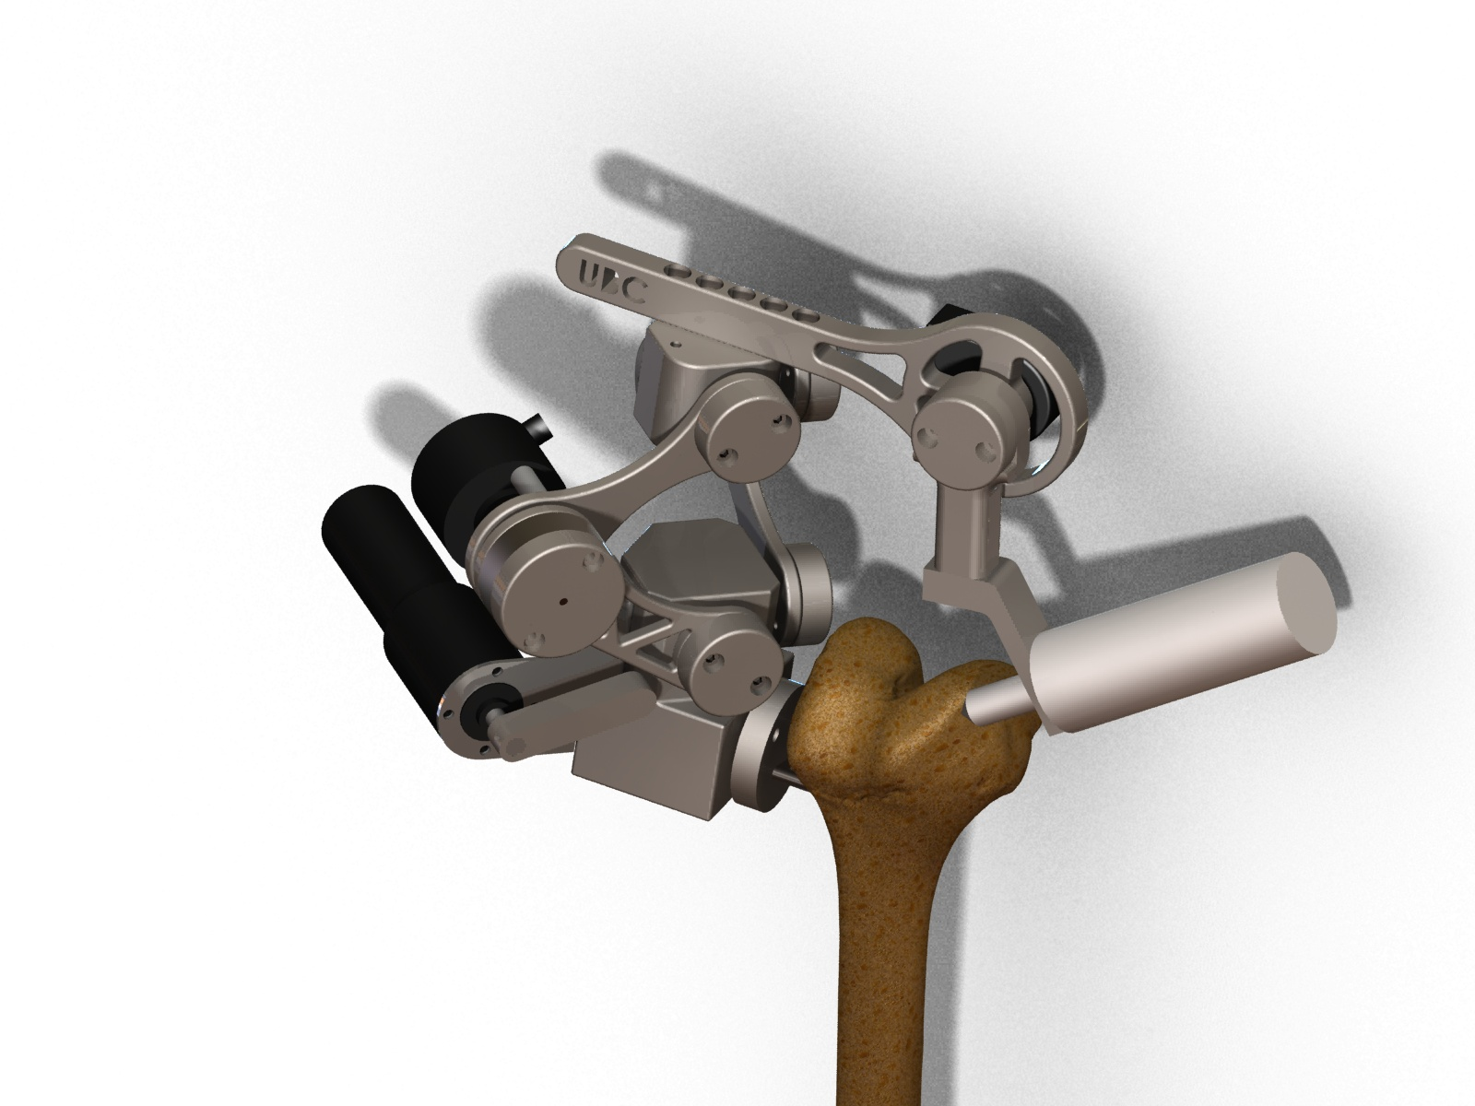

Figure : Solidworks rendering of the five link mechanism designed for the Praxim Surgical cadaver prototype

## 4.2 General size and weight optimization

The operating workspace and total weight of the device are two critical characteristics that ultimately determine the overall success of the design. Analysis was performed to maximize the potential workable area of the device by adjusting link lengths, while keeping the total weight of the device within the design requirements.

There are two critical parameters that must be adhered to in Praxia’s design: minimum workable area with a diameter of 63.5mm and a maximum total device weight of 5lbs. Any increase in workable area or decrease in the total weight of the device is beneficial to the design of the system based, however the opposite is detrimental. The final link lengths, shown in Table 1, were determined by maximizing the total allowable workable area while maintaining the weight of the links at approximately 2lbs.

Table : Final design link lengths

|  |  |
| --- | --- |
| Link | Length [cm] |
| 1 | 7 |
| 2 | 7 |
| 3 | 5 |
| 4 | 5 |
| 5 | 7 |

Table : Joint operating range

|  |  |
| --- | --- |
| Joint Angle | Range [degrees] |
| **Ɵ12 min** | 30 |
| **Ɵ12 max** | 120 |
| **Ɵ54 max** | 45 |
| **Ɵ3** | 20 |
| **Ɵ135** | -15 |

With the above link characteristics, the device has a workable area of 90mm. This range has been optimized based on the user requirements determined earlier on in the project. The length has also been selected to ensure that there is no interference between radial link encoder and the hard constraint motor…. Testing the Praxia prototype will further assess the user feel based on weight, and may require a reduction in the potential workable area in order to reduce the total link weight, thus improving the user’s level of satisfaction with the device. The complete link length optimization is included in Appendix B: Link Length Optimization Analysis.

## 4.3 Gravity Compensation

One of the primary focuses of the new design is to improve the user’s “feel” of the device (i.e. how cumbersome vs. how comfortable it may be to use). A critical design parameter of this criterion is the weight of the device (including the weight of the tool) that the user must support when the tool tip is away from the hard surface. Gravity compensation mechanisms can be implemented to transfer this load from the user to the support structure and bone mount. Two types of gravity compensation implementations were considered, and are as follows:

* **Rotational gravity compensation** that counteracts moments produced about the bone mount due to the weight and position of the device
* **Linear gravity compensation** that resists motion towards the bone mount, causing the radial link system to collapse

Gravity

Tool Weight

**LR:** Radial Links System  
**L3:** Vertical Offset Link  
**Dx:** Horizontal distance to bone mount joint

L3

LR

Bone Mount

θ R

θ23

Moment created at bone mount

x

z

Figure : Simplified linkage diagram highlighting rotational and linear gravity compensation

A technical assessment of rotational gravity compensation suggests that for the theoretical weight of the device, rotational gravity compensation is not necessary, and thus no rotational gravity compensation mechanism was designed. This assessment must be verified with user tests using a completed prototype.

Linear gravity compensation has been implemented by a tension spring mechanism that extends along the secondary support links of the radial link system. A simple position adjustment mechanism coupled to the rotating base facilitates fine spring tension tuning that will be optimized based on user feedback. User tests of the prototype will be user to optimize the spring tension for the desired operating range.

## 4.4 Link and Joint Design

The detailed design goals for the Praxia’s mechanical design are driven by the need to create a device that is lightweight and small enough to provide adequate user feel while minimizing the force exerted on the bone; furthermore, the device must meet all performance goals. As a result the joints have been designed using minimum constraint theory, and measures have been taken to ensure that the joints do not become loose over time. The Praxia prototype has been constructed from 304 stainless steel and is designed to integrate with Praxim’s bone mount. This section will discuss the major functions and provide an overview of the design for each component.

## Joint

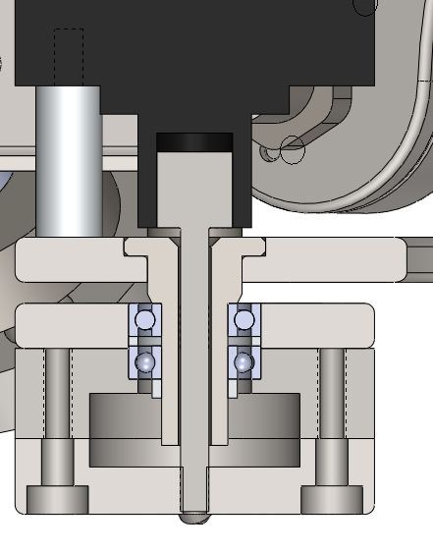

Figure : Cross section of links at joint highlight bearings, encoders and links

## Bone Mount Axle (BMA)

### Functions

The bone mount axle must attach to Praxim’s adjustable bone mount and allow the rotating base to freely move around it. The axel must be rigidly coupled to the encoder shaft, as the shaft determines the orientation of the rotating base with respect to the bone.

### Design Goals

* The bearings for the rotating base must be spaced as far apart as possible to minimize play in the joint
* Recess caps to minimize the size

### Design

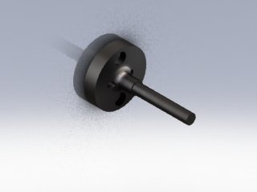

Figure : Model of Praxia’s bone mount including the bone mount axle

## Rotating Base (RB)

### Functions

The RB is the base attachment for the device. The RB couples the primary and secondary links for the radial linkage system to the BMA, also securing the hard constraint motor and BM encoder to the device.

### Design Goals

* Design to be as easily manufactured as possible
* Remove any unnecessary weight from the rest of the device, housing heavy components here

### Design Features

Link axles are designed to be threaded into the RB in order to avoid press fitting. The attachment points for the links are perpendicular to each other and angled 45 degrees away from the BMA to minimize interference with the soft tissue around the knee.

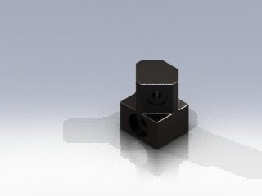

Figure : Model of Praxia’s rotating base

### Recommended Improvements

Casting this part would allow for more complicated geometry, which in turn may reduce the total amount of material required to accomplish its required functions and therefore reducing the weight of the part.

## Primary and Secondary Links (PL1 and PL2)

### Functions

The primary and secondary links combine to generate a radial link system that constrains the upper connection block (link 3) to move linearly with respect to the RB. The primary links facilitates the physical constraint preventing motion past a defined linear distance between the RB and link 3.

### Design Goals

* Minimize the size and weight of the links
* Accept hard constraint at PL1
* Implement shape that simplifies the motor positioning function
* Minimize the size of the joints between the two primary links and the two secondary links.

### Design Features

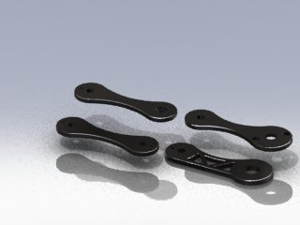

Figure : Model of the PL1, PL2, SL1, SL2 that make up the radial link system

*Link Size:*

The physical constraint function is simplified by keeping the primary links equal in length and size. 70mm links provide the necessary operating envelope and reduce the possibility of collisions between the primary link encoder and the physical constraint motor.

*Link Profile:*

All of the links, except PL1, have a peanut shape in order to reduce the weight of the links. PL1 has the peanut profile on the top half of the link, but the bottom half of the link is a straight edge in order to provide an edge for the physical constraint to act upon.

### Recommended Improvements

The joints have been designed to be a small as possible while still providing minimal play, but a possible improvement to the design would be to simplify the machining process for these links as much as possible. Simplifying the joint design could lead to a much easier and faster assembly of the device, and reduce critical tolerances by minimizing machining error.

* Specifics of Bearing and encoder selection/design WRT to overall size of device
* Specifics relating to looseness
* Specifics relating to manufacturing

## Horizontal Offset:

### Functions

The horizontal offset acts as a connection between the up-down motion of the primary links and the rotational motion of the links on which the tool is mounted on. The horizontal attachment is rigidly fixed to the upper rotating block on one end, and is coupled with link 5 (tool mount link) on the other. The coupling with the tool mount link incorporates an encoder, to be able to determine the position of the tool bit at all times.

### Design Goals

* Rigidity is crucial, as any deflection is a direct intrusion into the hard surface
* Remove unnecessary weight
* Allow for multiple lengths to cater to different surgical requirements

### Design Features

The link is designed to be mounted above the upper rotating block with hex cap screws. An array of predrilled holes will allow for the interchanging of the link length depending on the surgery. On the tool mount side, the link width expands to a circular shape to allow for the mounting of an encoder on the back side. A through hole is made so that the encoder shaft can interact with the tool mount link on the front side.

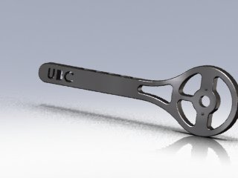

Figure : Model of horizontal offset link

### Recommended Improvements

A reduction in the link size can be achieved if a smaller encoder is found, that achieves the required precision and mounting orientation. Also, a more convenient length interchanging design could be implemented, which can allow “on-the-fly” length changes during the surgery itself, rather than dismantling the whole link and assembling it to the new size.

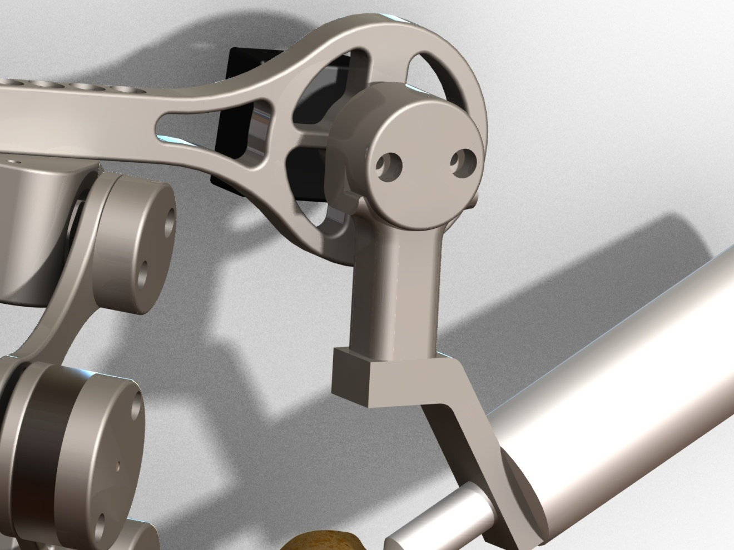

Figure : Model highlighting encoder position at the joint between link 4 and link 5

## Link 5 (L5):

### Functions

Link 5 is a crucial part of the design, since its movement allows for the negotiation of curves in the hard surface more than the other dynamic links of the robot. Link 5 rotates about a shaft which is coaxial to the encoder shaft running through the horizontal offset. Thus, link 5 rotates in a plane parallel to the horizontal offset link. The movement of link 5 adds width and depth to the workable area.

### Design Goals

* Minimize resistance to user movement (as smooth as possible)
* Remove unnecessary weight
* Reduce size, without compromising load-bearing capability

### Design Features

The link is designed to simply be a downward vertical addition to the horizontal offset, able to rotate about a joint shaft between them. It comprises of two parts, the actual vertical link, and the cap. The link itself tackles the main functionality of providing a downward vertical arm for the robot, while the cap houses the bearing assembly (for smooth motion) and serves as the end-mount for the encoder shaft. Since the encoder is mounted on the “static” horizontal offset, the motion of link 5 can be determined by simply measuring the rotation of the encoder shaft.

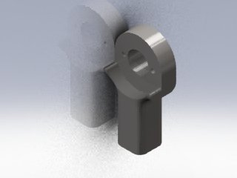

Figure : Model of Link 5

### Recommended Improvements

An amalgamation of link 5 and the tool mount link (described below) could allow for a more compact and light weight design.

## Tool Mount Link:

### Functions

The tool mount link is the final link of the design and is the one on which the surgical tool is mounted. The link allows for rotation about the axis of link 5, thus giving the surgeon the ability to hold the tool from virtually any angle. The tool mount link does not allow translational movement in itself, however, as it is attached to link 5 and the rest of the structure, it also moves in the up-down direction as allowed by the primary links.

### Design Goals

* Full 360° freedom rotation about the link 5 axis
* Maintain structural integrity while bearing the full weight of the tool

### Design Features

The tool mount link is designed to couple with bottom of link 5 with a joint fastener (shoulder screw) that threads into link 5, providing the necessary constraint against translational movement and allowing the free rotational movement. The interface between the link and the tool is at an angle in order for the tool bit to always touch the cutting surface using its side, for optimal cutting performance.

Tool mont link picture here.

### Recommended Improvements

Making the tool rotation with respect to the tool mount link lets the surgeon’s hand follow a more natural and comfortable sculpting motion. This additional degree of freedom does not improve the function of Praxia itself, but allows the surgeon to be less constrained and more relaxed during the surgical procedure.

## 4.6 Error Minimization

For the device to be practical, the result of the assisted cut must maintain implant frontal plane alignment accuracy to within 3°, meaning that the physical restraint must prevent no more than 0.5mm of penetration (Plaskos, 2005). The physical restraint must also respond with sufficient speed, at a rate of 1 kHz (Hungr). Assuming that mechanical play is negligible, the precision and accuracy of the device is limited by encoder resolution and update speed.

To achieve less than 0.5mm of penetration, the encoders were chosen for the highest precision in the smallest sizes available. The following table shows the details of the encoders and the respective links that they are attached to. Full specifications can be found in the appendices.

Table : Encoder models and resolutions

|  |  |
| --- | --- |
| Rotating Base | 1000PPR (4,000 effective CPR) – AME-1000V-T600K |
| Links 1-2 | 2500PPR (10,000 effective CPR) – TRD-SH2500VD |
| Links 4-5 | 1000PPR (4,000 effective CPR) – AME-1000V-T600K |

Using this combination of encoders, penetration is limited to an absolute theoretical maximum of 0.166mm relative to the axle of the bone mount.

To achieve an update rate of 1 kHz, a 600Mhz microprocessor with an FPU (Floating-Point Unit) is selected to perform all the data processing. The previous group of students had all processing performed on a 16Mhz microcontroller; however, analysis in the Technical Analysis Report shows that this microcontroller is incapable of achieving the necessary speed due to the lack of an FPU. Due to having only one computer/electrical engineer on the present team, the microcontroller was kept to serve as an interface between the microprocessor and the encoders/motor to reduce development time.



Figure : Praxia electrical block diagram

The OMAP3530 microprocessor is connected to the AT90CAN128 microcontroller via RS232 serial interface at 57600 baud. The microcontroller keeps track of the positions of the encoders and transmits them to the OMAP3530, which determines where the end-effecter is relative to the virtual surface using forward kinematics. A blocker position is then calculated and transmitted to the microcontroller, where it is then relayed to the motor controller via the CAN interface. Surfaces are pre-programmed with equations for simplicity.



Figure : Praxia’s complete electrical layout

The QNX Neutrino operating system was selected to run on the OMAP3530 for its real-time guarantee for applications running on embedded systems. It also provides a developer-friendly environment to develop and debug applications over serial or Ethernet.

At the time of writing, the device did not progresses far enough to verify the functionality and performance of the control system. However, due to the speed limitations of the RS232 serial interface, the overall speed of the system can only achieve 90% of the 1 kHz requirement at 900Hz. One solution is to use a faster interface like the Two-wire interface. For a production system, a better solution is to use a single microcontroller capable of processing floating-point math. The TI Stellaris with an ARM Cortex M4 core would be a good candidate.

# Conclusion

The two primary concept goals the Praxia prototype must meet in order to implement an effective surgical tool for UKAs are as follows:

1. Device Performance: Does the device perform the required tasks specified in design conceptualization?
2. User Interface: Is the device user-friendly? How well does the device interact with the user?

Tests have been designed to evaluate the prototype design based on these goals.

## 5.1 Device Performance Tests

The device performance tests determine whether the device will provide the precision and accuracy necessary to be considered an acceptable surgical aid. Concept specifications require the hard surface constraint to be physically imposed within 0.5mm of the desired model surface. This means that the device must recognize the current position of the tool, within a 0.5mm tolerance, based on all encoder readings and any play in linkage joints. The device must also provide a total workspace large enough to install a common uni-compartmental knee implant. This implant can be approximated as a circle with a radius of 63.6mm.

### Precision, accuracy and workable area testing

In order to assess the precision of the device, the position/location of a number of points on Praxia must be known to a greater accuracy than the required precision of the device. This is achieved by using a mill with a known accuracy of +/-0.05mm to locate and mark four calibration positions on a piece of carbon steel with a coefficient of linear expansion of 13.0E-6 m/m K. Allowing for a 100K temperature variation, the mark positions will be known within +/-0.05mm. The device accuracy can be determined by comparing the device location with the actual position of the milled marks.

### Instability

Tests of previous prototypes identify the presence of instabilities at discontinuous positions (corners and locations where two curves meet) and near the edge of the hard surface. The effective position of the hard surface position and any potential instability can be determined by tracing the outline of various hard surfaces and attempting to penetrate the hard surface.

### Results

Testing has not been completed

## 5.2 User Interface

The user feel of the device is essential for widespread acceptance, and has been a major focus of the current design. Previous prototypes confirm that 3D haptic surfaces can be implemented, but prove difficult to control due to a resistance to user movement (termed “virtual weight”). User based tests will be used to determine the effectiveness of the device as a bone sculpting tool.

# Recommendations

User tests and performance evaluations have not been completed because the prototype is not yet fully functional. Basic performance tests have been used to evaluate the encoder performance based on the update speed and the consistency of each reading, and the software has been verified using hand calculations. The majority of the mechanical aspects of the design require user tests, but an evaluation of the manufacturing techniques can be provided based on machining and fabrication analysis. Once prototype construction and user tests have been completed, a review of the prototype will be presented to the client and a formal list of recommendations will be compiled from the findings.

### Encoder Performance

The encoders pick up 100% of repositions and position the tool within 0.17mm of the desired location, if mechanical play is ignored. This allows for 0.3mm of additional error from the bone mount joint, play at the links, and software rounding errors. The design uses relative encoders and the total performance may be limited by accuracy of the calibration position as a result. The calibration position accuracy will not be known until the prototype has been completely manufactured.

### Software Positioning Error

The software designed takes encoder input and computes the desired user position. Related error occurs due to rounding in the position identification and bugs in the software the computer the wrong position in certain circumstances. No errors have been found in current version of the code and all variables maintain 16 decimal places, so there is negligible error in the software as a result.

### Link Joint Play

Manufacture of the prototype has been rushed, resulting in a significant increase in play in the joints. An assessment of the maximum in the primary hard constraint joints shows play in the joints of approximately 5 degrees, amounting to +/-6mm of error. Combining the primary and secondary links to create the radial link structure reduces the error to 1mm; however this error is unacceptable for surgical purposes. Manufacturing techniques must be considered further to ensure the desired tolerances for critical components can be met.

### Manufacturing

Manufacturing of the prototype has been completed using a combination of water jet cutting and machining. The complexity of the links necessary to reduce the overall weight of the system makes accurate machining difficult. As a result, a combination of casting and CNC is recommended for additional devices. Casting should be used for the rotating base and the tool mount while minor changes made to the current design could allow for complete manufactured using water jet and CNC. Component specific recommendations have been included in the detailed mechanical design section. Manufacturing drawings are included in

**6.0 References and Appendices**

**6.1 References**

1. Mech451/2 Praxim Project Final Report, 2008

2. Haptic Emulation of Hard Surfaces with Applications to Orthopaedic Surgery, Nikolai Hungr, 2008

# Appendix A: Limitations of Existing Knee Arthroplasty Devices

The following is a list of failures of existing knee arthroplasty surgical aids:

* Bone damage due to improper surgical procedure or excessive forces causing mechanical failure in the device or the bone structure
* Loosening of device components (any or all) due to improper device placement or fastening or due to forces exceeding the tolerance threshold of the device post-operation (implants)
* Allergic reaction to any of the device components or elements which the body is exposed to during the implantation procedure
* Infection related to surgery from improper sterilization of equipment or the surgical environment or improper sterile practices of the surgical staff
* Loss of neurological function or impairment of neurological function due to insults or obstructions to the nervous system (during surgery and after completion)
* Cardiovascular damage, including hemorrhage from improper healing during or post-operation as well as damage to bone vasculature
* Mechanical failure of the device such as loosening of its connection(s) with the bones.
* Early failure of implant due to asymmetric loading, which is a direct cause of inaccurate bone-shaping and/or referencing
* Poor knee mechanics and/or loosening of the components due to improper implant alignment with respect to bones and soft tissues (direct cause of inaccurate surface shaping)

# Appendix B: Link Length Optimization Analysis

An essential calculation which had to be completed before moving on to other analyses is that of the linkage lengths (most importantly Link1 and Link 2) and their corresponding “workable” area. In this analysis, we try to maximize the link lengths to maximize the workable area which can be sculpted using the tool bit. At the same time, the link sizes should not be too large in order to minimize size and weight of the overall device. Thus, a balance must be struck between link sizes and workable area. The following user satisfaction curves illustrate the relative importance of each:

Cannot reach most critical points on a normal-sized knee

Can reach most critical points of a normal-sized knee

Can reach all points on a large-sized knee

From the graphs, it can be seen that the link weights are slightly more important for user satisfaction, and thus, the structural design focus will be to reduce link size (and weight) more than to achieve a larger workable area than what’s functionally needed.

This section of the report explains the theory behind the link size calculations and how we determined them to be within discrete ranges. First of all we must define how we express the workable area at the tool bit. From the *Matlab* plots results discussed in the CFP, we already know the general shape of these areas. They can be *approximated* as the area between two circular boundaries, one boundary of which is larger than the other. Thus, we define the outer or larger curved boundary as Rmax and the inner our smaller curved boundary as Rmin. The side boundaries of the workable area are approximated as straight vertical lines, and the distance between them is called Rangex. Thus, the workable area looks like the following (note: in reality, the origins of the radii should be different, but this is a very close approximation):

Rmin

Rmax

Rangex

With the workspace coordinates defined, we must also define the variables of the linkage design in order to optimize the linkage sizes. The linkage variables are vital for the analysis and are defined in the figure below. The figure is a simplified illustration of the linkage orientation, with the square point representing the bone mount and the circular point representing the cutting tool. The legend to the left identifies the link names.

L3

LR

L5

θ3-5

θ5

R

Bone Mount

Tool

Bit

**LR:** Radial Link

**L3:** Vertical Offset Link

**L5:** Tool Link (resultant length)

y

z

With the configuration above, we need to maximize the workable area while, at the same time, minimizing link lengths. The goal of the following analysis is to optimize the link lengths and workable area. We perform the analysis by first computing a mathematical relationship of the workable area based on the link lengths and angles defined in the figure above.

To start, we write the following geometric relationships between distances and angles:

(note: L1 , L2 and θ12 are not shown in the diagram)

We will create a virtual length called L’5:

L’5 = L5cosθ5

With that new virtual length, we can define the “reachable” length in the “z” and “y” directions stated above:

90 - )

90 - )

Since the “z” and “y” lengths described above are components of the R vector, we can compute the length of R simply as follows:

R is the range vector which characterizes the size of the workable area in our analysis.

Knowing the mathematical relationship between link lengths (sizes) and workable area, our task is to find an optimized combination, which gives us both a satisfactory workable area and a reasonable size and weight for the device. We do so with an excel spreadsheet. We insert the variables and equations above into the spreadsheet, and observe the change in workable area based on links 1 and 2. It is known that the workable area increases with increasing link sizes, however, our goal was to pinpoint the “plateau” of the relationship. The spreadsheet allowed us to quickly and accurately calculate the minimum and maximum radius values, along with the full range, with different combinations of theta values. An example is given below.

|  |  |  |  |  |  |
| --- | --- | --- | --- | --- | --- |
| **Link** | **Length** |  |  | **Theta_12_min** | 30 |
| 1 | 7 |  |  | **Theta_12_max** | 120 |
| 2 | 7 |  |  | **Theta_5_max** | 45 |
| 3 | 5 |  |  | **Theta_3** | 20 |
| 4 | 5 |  |  | **Theta_35** | -15 |
| 5 | 7 |  |  |  |  |
|  |  |  |  |  |  |
| **r_min** | 1.740303 |  |  |  |  |
| **r_max** | 9.910691 |  |  |  |  |
| **Range_x** | 9.899495 |  |  |  |  |

By inserting various combinations of link sizes into the spreadsheet, we observed a preliminary viable option. It gave us a large workable area while not overly extending the length of the links, and happened when both links 1 and 2 are equal in length and measure 7 cm. Our next task was to perform a sensitivity analysis and verification of this preliminary result, and we did that using Matlab.

First, we plotted the combined weight of 7 links versus the length of each link. This is done by assuming a rectangular slab for each link and the following formula:



Figure 12: Weight (lb) vs. Link Length (cm)

Based on the user satisfaction curve vs. the device total weight, we should not go beyond 5 lb for the device as a whole. Thus, the links alone, without the motors, encoders and other equipment, should not be more than approximately 2 lb – corresponding to around a 7 cm link length. This verifies that the preliminary result of a 7 cm link size does not conflict our weight requirements. However, we must still check whether it conflicts with our workable area requirements. To check that the link lengths which fall below the maximum acceptable weight also give us an acceptable workable area, we plot the mathematical range relationship in Matlab. The following workable area relations are entered:

L’5 = L5cosθ5

90 - )

90 - )

Plotting the workable area range versus the link size, we get the following graph. On the plot, a link size of 7 cm corresponds to a workable range of approximately 90 mm, or 9 cm. This value is greater than the standard implant size that we aim to achieve, thus, a link size of 7 cm is both acceptable for maximum weight constraints and minimum workable area constraints.



The Matlab code for the analysis described above can be found in the Appendix.

*>> y = x.^2 + x.^2 -2.*x.*x.*cos(30) + 5*cos(20) - 7*cos(45)*cos(90-20+15);*

*>> z = y;*

*>> y = -5*cos(20) + 7*cos(45)*cos(90-20+15);*

*>> R = sqrt(z.^2 + y^2);*

*>> plot(x,R)*

*>> density = 8.03;*

*>> conversion = .0022046;*

*>> weight = x*2*1*density*conversion;*

*>> f = 7.*weight;*

*>> plot(x,f)*

*>> plot(x,f)*

# Appendix C: Testing Procedures

The testing procedures for the Praxia user and precision/accuracy tests are included here.

|  |  |  |
| --- | --- | --- |
| Step | Task | Comments |
| 1. | **Mill Calibration Positions**   |  |  | | --- | --- | | 1. | Clamp an approximately 6cm by 6cm by 1cm piece of scrap carbon steel in the mill vice. | | 2. | Use edge finder tool to position the mill at a corner of the steel. Replace edge finder with a 0.2mm drill bit and reposition the z-coordinate at the surface of the device. Zero all dimensions. | | 3. | Use the mill to make holes 1mm deep holes at four positions [(40mm, 40mm); (40mm, 10mm); (10mm, 40mm); (10mm, 10mm)] | | 4. | Clamp steel in a vertical orientation and complete steps 1.2 and 1.3 at [(5mm, 10mm); (5mm, 40mm)] | | Try to drill each hole quickly and use coolant to avoid heating metal excessively. Actual position of calibration points may vary. Record any changes on the testing procedure. |
| 2. | **Create holes for bone mount**   |  |  | | --- | --- | | 1. | On a flat surface of the steel create two 5mm holes 10mm apart using a 2.5mm drill bit. | | 2. | Tap the holes using a 3.3mm tap | |  |
| 3. | **Device Precision**   |  |  | | --- | --- | | 1. | Connect device to carbon steel piece designed above through the bone mount using two m3 screws | | 2. | Connect a pin to the tool end so that the pin head is positioned at the centre of the radius of curvature of the tool. | | 3. | Place the tool at the calibration corner of the steel piece and record the encoder determined position. | | 4. | Place the tool at the marks located at [(40mm, 40mm); (40mm, 10mm); (10mm, 40mm); (10mm, 10mm)] and record the encoder determined position. | | 5. | Place the tool at the marks located at [(5mm, 10mm); (5mm, 40mm)] in the vertical plane and record the encoder determined position. | |  |
| 4. | **Device Accuracy**   |  |  | | --- | --- | | 1. | Repeat step 3 five times | | 2. | Graph the actual mark positions as well as each test position. | |  |
| 5. | **Workable Area**   |  |  | | --- | --- | | 1. | Position tool at the calibration corner with a piece of paper positioned below the steel piece. | | 2. | Trace the tool head through each of the steel marks and ensure the tool head does not leave the surface of the steel piece. Can this be completed effectively? | | 3. | Move the tool head towards each of the corners of the piece of paper. Record the device reach to each of the corners on the piece of paper. | | 4. | Keeping the x and y coordinates the same as step 5.3 record the highest possible vertical position. | | This test does not determine the volume of the device, but provides a basic footprint range and will verify that the device will be effective for the implant sizes considered. |

|  |  |  |
| --- | --- | --- |
| Step | Task | Comments |
| 6. | **Hard Surface**   |  |  | | --- | --- | | 1. | Clamp a piece of foam to the steel testing piece created in step 1. | | 2. | Implement four models into the system (flat, spherical bulge, cone and pyramid) | | 3. | Slowly trace the surface of the foam for each of the shapes, removing excess material and revealed the implemented shape. Not down any positions where the tool head penetrates the hard surface | | 4. | Place the tool head at any corners. Access the stability of the tool at these locations. | | Tool should not penetrate the hard surface. |
| 7. | **Instability**   |  |  | | --- | --- | | 1. | For each of the shapes implemented above place the tool head at any corners. Access the stability of the tool at these locations. | | Tool instability should be maintained to within +/- 1mm. |

|  |  |  |
| --- | --- | --- |
| Step | Task | Comments |
| 8. | **Virtual Weight**   |  |  | | --- | --- | | 1. | For each user: Setup device using foam and implement a hemi spherical hard surface. The foam must be cut to within 5mm of the hard surface prior to testing. | | 2. | With a black pen, place point pairs 5cm apart in a zigzag pattern at 1 cm intervals and mark transition paths across the surface points – use a total of 10 points. | | 3. | In an orientation perpendicular to the step 8.2, repeat step 8.2. | | 4. | Position user 45 degrees from the bone mount position and a line connecting the hip and the knee. | | 5. | Make user follow the zigzag paths described in 8.2 and 8.3, pausing at each point for 5 seconds. Each transition should take between 3 and 5 seconds. | | 6. | Ask user to rate the device performance based on the scale shown in step 8 comments. | | 7. | Ask user to provide general comments on the perceived effectiveness of the device for high precision cutting applications. | | 8. | Measure and record the maximum error between the cut path and desired path. | | Testing using foam will not provide the same resistance as a bone, but be used to assess the effects of the weight of the device on the user in different orientations while performing surgical type operations. The user assessment scale is based on the user’s perceived control over the position of the device and the user’s ability to maneuver the tool along a specific path.   |  |  | | --- | --- | | Rating | Description | | 1. | Device is uncomfortable to hold, will not follow desired path and requires excessive effort to maintain position | | 2. |  | | 3. | Device is uncomfortable to hold, somewhat follow desired path and requires effort to maintain position | | 4. |  | | 5. | Device is uncomfortable to hold, follows desired path and requires effort to maintain position | | 6. |  | | 7. | Device is comfortable to hold, follows desired path well and can maintain position with limited input | | 8. |  | | 9. | Device is comfortable to hold, follows desired path well and can maintain position without user input | | 10. | Device does not affect user control of the tool. | |
| 9. | **Accessibility**   |  |  | | --- | --- | | 1. | For each user: Setup device using foam and implement a hemi spherical hard surface. The foam must be cut to within 5mm of the hard surface prior to testing. | | 2. | With a black pen, place point pairs 5cm apart in a zigzag pattern at 1 cm intervals and mark transition paths across the surface points – use a total of 10 points. | | 3. | In an orientation perpendicular to the step 8.2, repeat step 8.2. | | 4. | Position user 45 degrees from the bone mount position and a line connecting the hip and the knee. | | 5. | Make user follow the zigzag paths described in 9.2 and 8.3, pausing at each point for 5 seconds. Each transition should take between 3 and 5 seconds. | | 6. | Ask user to rate the device performance based on the scale shown in step 9 comments. | | 7. | Ask user to provide general comments on the perceived effectiveness of the device for high precision cutting applications. | | 8. | Measure and record the maximum error between the cut path and desired path. | | This assessment should be completed by experienced surgeons.   |  |  | | --- | --- | | Rating | Description | | 1. | Device is does not provide access critical locations | | 2. |  | | 3. |  | | 4. |  | | 5. | Device is allows access the all critical locations, but requires undesirable repositioning of hand | | 6. |  | | 7. |  | | 8. |  | | 9. |  | | 10. | Device provides comfortable access to all desired areas. | |

# Appendix D: Manufacturing Drawings

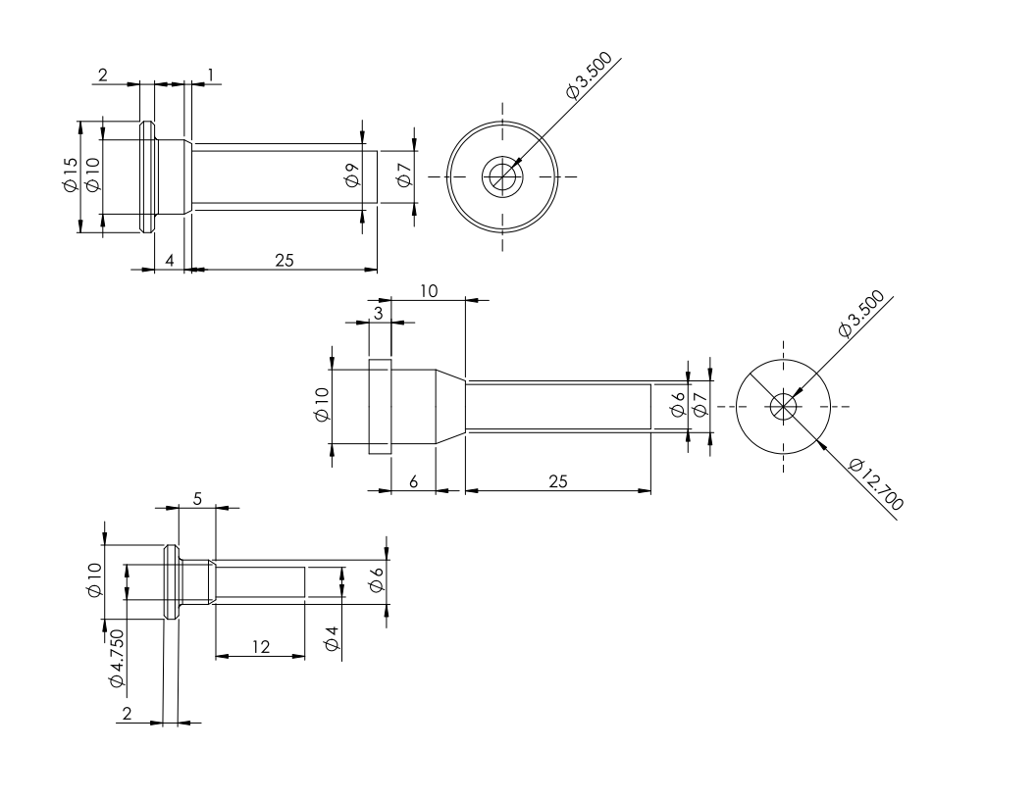

Figure : Axle drawings to be machined on a lathe

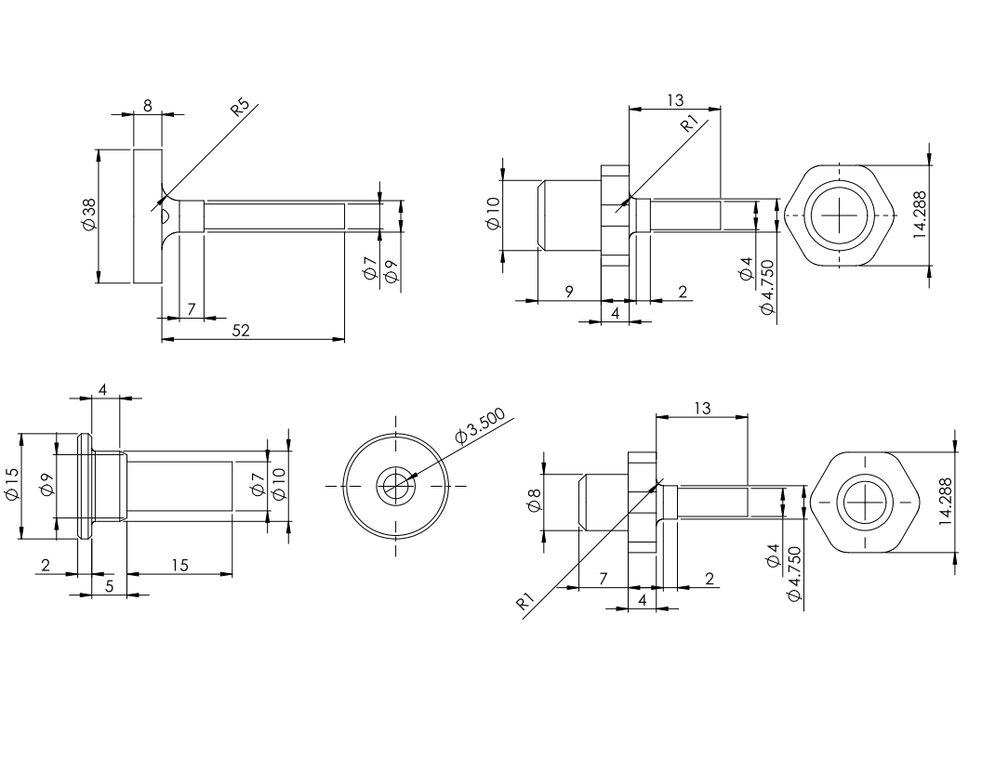

Figure : Additional axle drawings to be machined on a lathe

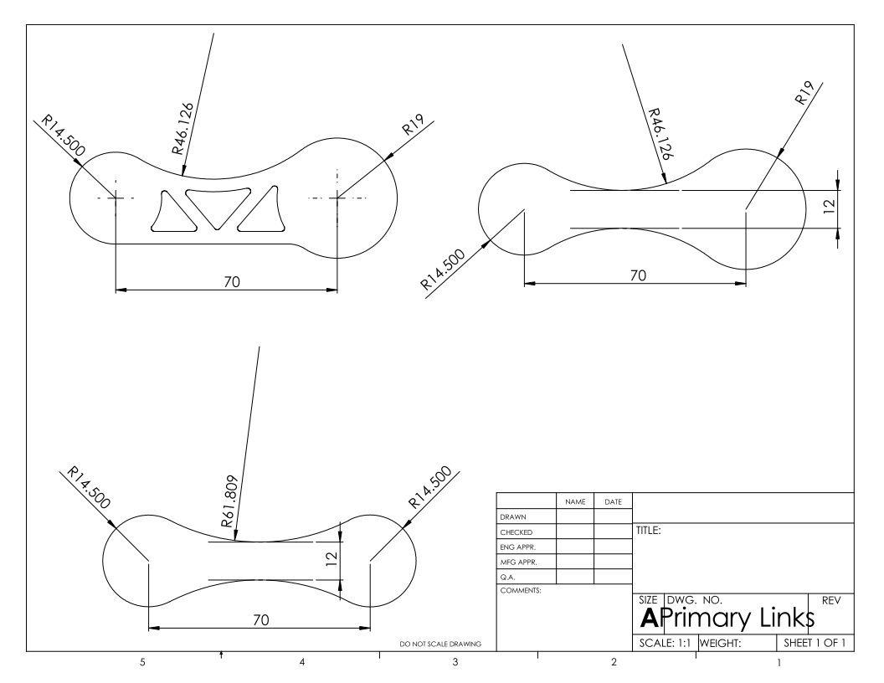

Figure : Link drawings to be water jet cut and drilled on a mill

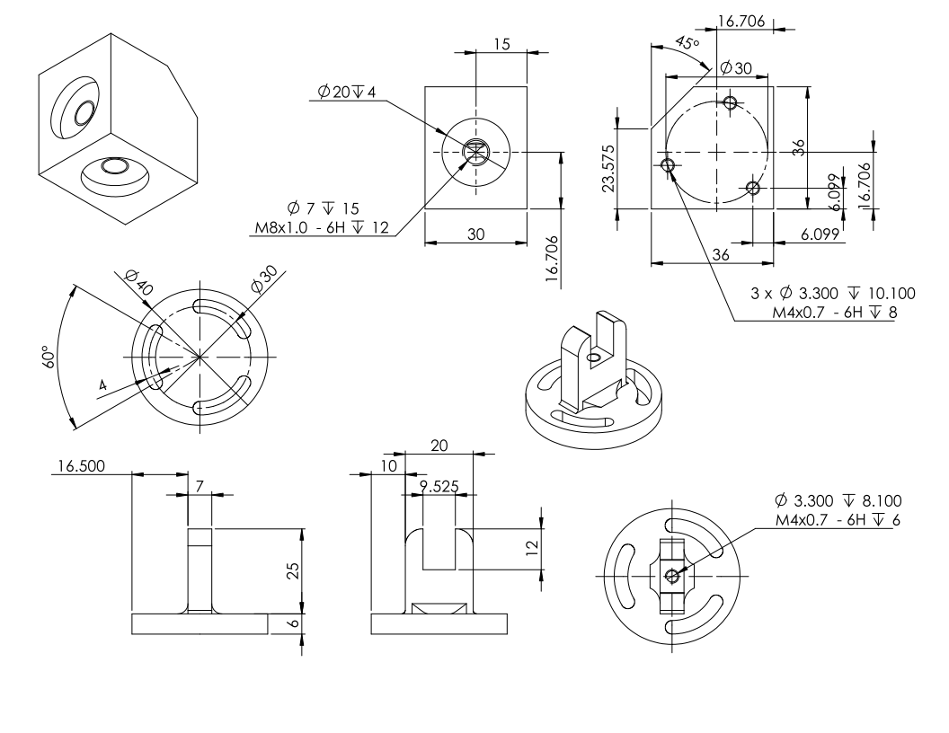

Figure : The rotating base drawings and vertical offset link designed to be milled

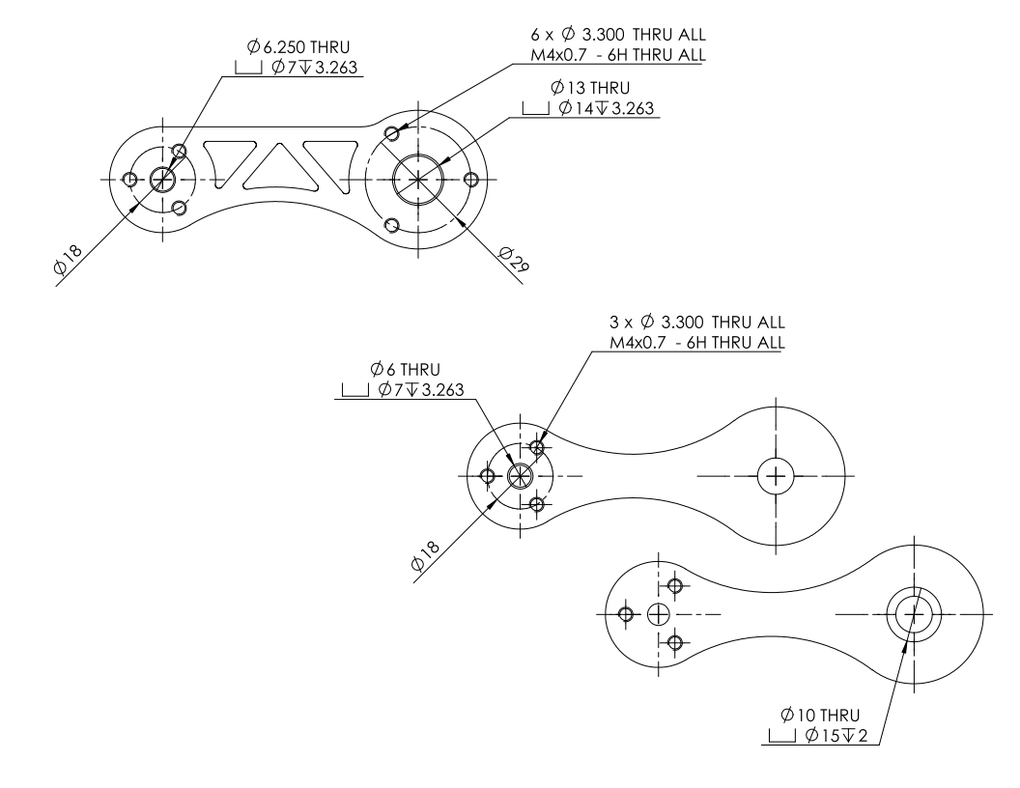

Figure : Primary links to be water jet cut and machined on a mill

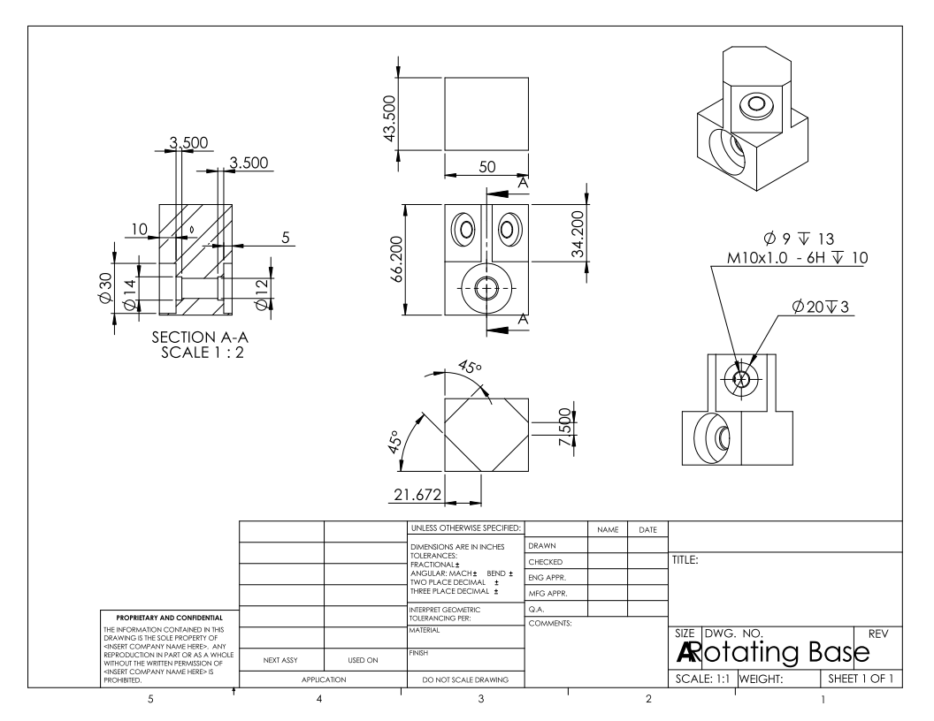

Figure : Rotating base design

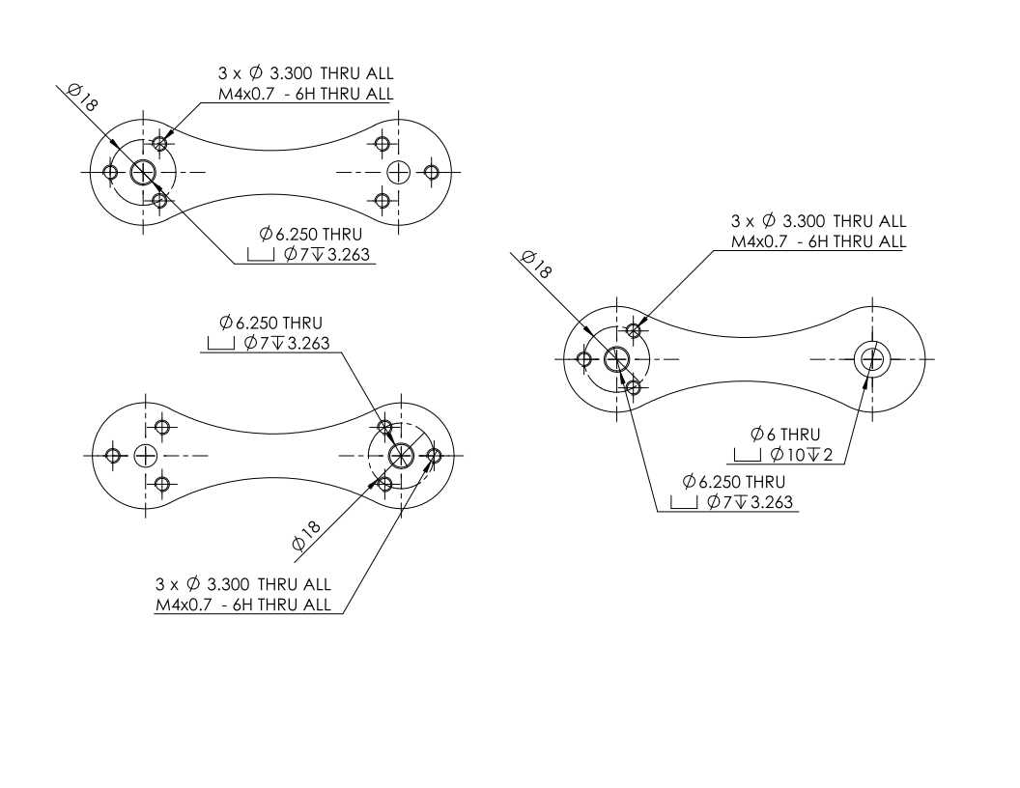

Figure : Secondary links designed to be water jet cut and drilled on a mill